**Political Parties**

**A. Vocabulary.** Match each key term with its definition. Each key term in the word bank will only be used once.

|  |  |  |  |  |
| --- | --- | --- | --- | --- |
| political party | write-in candidate | public policy | minority party | third party |
| platform | political views | ~~ballot access~~ | candidate | majority party |

|  |  |
| --- | --- |
| **DEFINITION** | **KEY TERM** |
| 1. Allowing a political party to put a candidate on the ballot | Ballot access |
| 2. A person’s ideas about how government should run and how issues should be solved |  |
| 3. A candidate whose name a voter must hand-write on the ballot |  |
| 4. Political party with the most elected members |  |
| 5. The stand the government takes about how issues should be handled |  |
| 6. A political party other than Republican or Democratic |  |
| 7. An organized group of people who share similar political views and work to influence government |  |
| 8. Set of statements describing a party’s views on major issues |  |
| 9. Political party that does not have a majority of the elected  members |  |
| 10. A person running for political office |  |

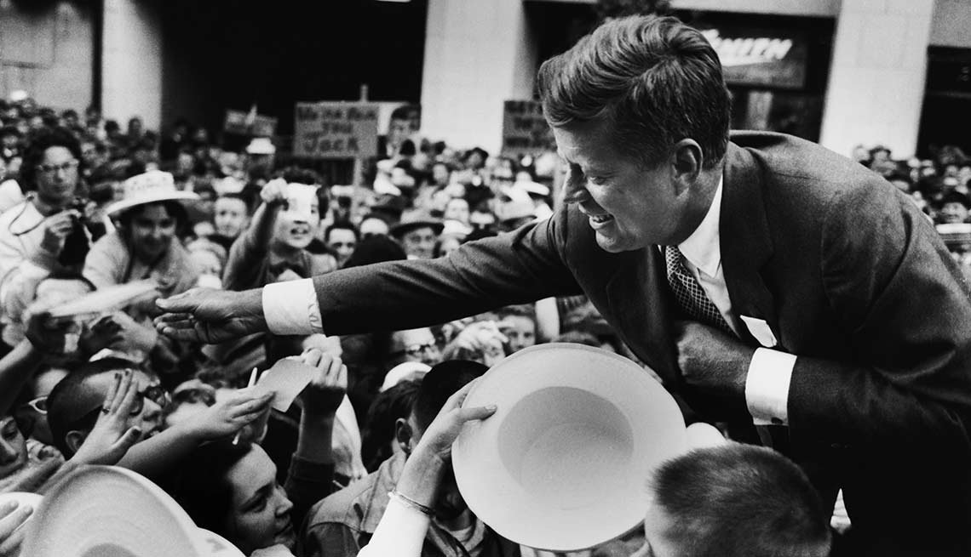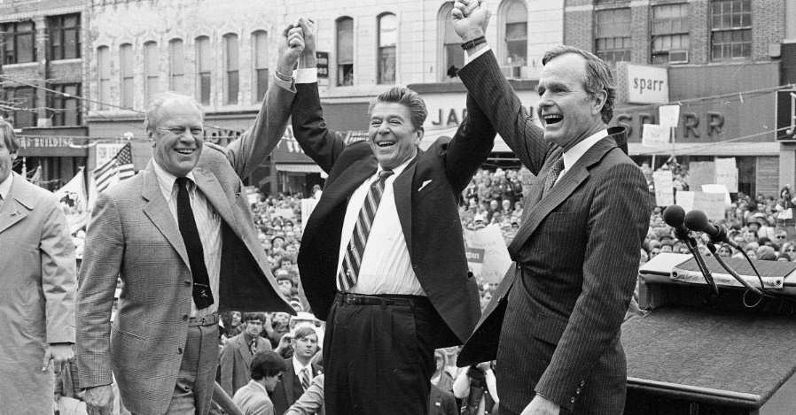

**B. True or False.** Read each statement and decide if it is true or false. Type in “True” or “False” in the empty box next to each statement. The statements will go in order in the reading. You will have 5 true statements and 6 false statements.

|  |  |
| --- | --- |
| **True OR False?** | **STATEMENT** |
| True | 11. By forming a political party, people gain more influence over government by banding together with others. |
|  | 12. Although third parties exist, the United States is mostly a two-party system. |
|  | 13. The two major parties in the United States are the Libertarians and Greens. |
|  | 14. People who are politically independent are members of **neither** the Republican nor Democratic Parties. |
|  | 15. All political parties have equal access to put candidates on the ballot. |
|  | 16. A party platform is a stage where candidates stand when they speak to crowds. |
|  | 17. Political parties work at all levels of government—national, state, and local. |
|  | 18. In the U.S. Congress and most state legislatures, Republicans and Democrats are split into a majority party and a minority party. |
|  | 19. The president or governor’s political party has no effect on the lawmaking process. |
|  | 20. You can only vote for a candidate who is the same party as the party you’re registered with. |
|  | 21. When you register to vote, you must join a political party. |

 

**C. Registered Voter!** Read each registered voter’s statement. Then, decide how each voter is probably registered. Be careful—some have more than one correct possibility! Mark all that you think could apply.

|  |  |  |
| --- | --- | --- |
| Write the parties that they could belong to in the box below: | Write the party that they could belong to in the box below: | Write the party that they could belong to in the box below: |
| Third Party  Republican/Democrat |  |  |
|  |  |  |
| Write the parties that they could belong to in the box below: | Write the party that they could belong to in the box below: | Write the party that they could belong to in the box below: |
|  |  |  |
|  |  |  |